Tell everyone to plant and preserve native trees!
I promise to display this sticker where others can see it.

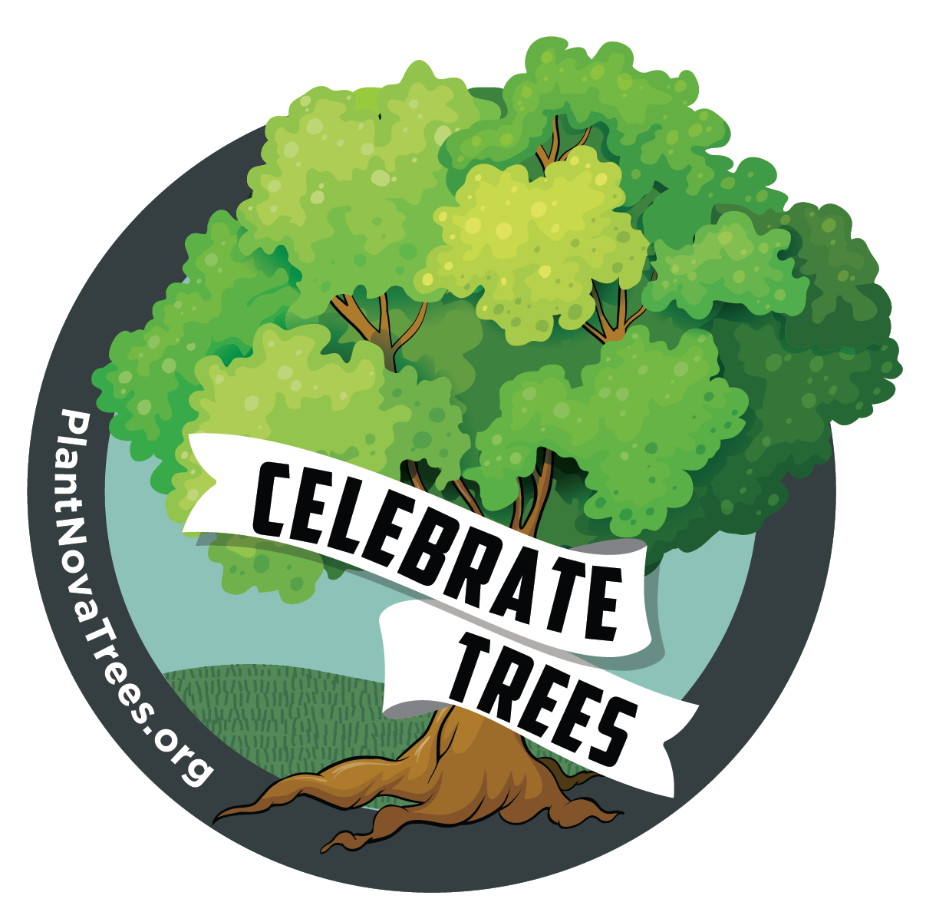

#plantnovatrees

